**456/2**

**MATHEMATICS PAPER 2**

**JULY / AUGUST 2017**

**2 ½ HOURS**

**ST. JOSEPH OF NAZARETH HIGH SCHOOL**

**INTERNAL MOCKS EXAMINATION 2017**

**S.4 MATHEMATICS**

**PAPER 2**

**TIME: 2 ½ HOURS**

**INSTRUCTIONS:**

* Attempt **all** the questions in Section **A** and any **five** questions from section **B**.
* Each question in Section A takes 4 marks and each in Section B takes 12 marks.
* Mathematical tables and scientific calculators may be used.
* Answers should all be written in the booklets provided.
* Graph paper is provided

**SECTION A (40 MARKS)**

1. Simplify: (04 marks)
2. Find the equation of a line which passes through and is perpendicular to the line whose equation is . (04 marks)

1. Given that point is and ; find

(i) the coordinates of

(ii) modulus of ; where is the origin.

(04 marks)

1. Find the area in represented by on a map whose scale is

. (04 marks)

1. The volume of a cylinder is . Find its diameter if its height is
2. marks)
3. The cash price of a mattress is shs. . Its hire purchase price is

higher than the cash price. A buyer pays monthly installments

of each after paying a deposit. Find the amount paid as a deposit.

(04 marks)

1. A class of students had to choose between Computer and Sub math)

in their combinations. chose Sub math while chose Computer. The

number of students who chose both subjects is half the number of those who

do not like any of the two subjects. Find the number of students that like both subjects. (04 marks)

1. Given that varies directly as and inversely as the square of . Find the

percentage change in if is increased by **20%** and at the same time is

increased by **50%**. (04 marks)

1. Express in form of and state the values of and (04 marks)
2. If are integers. Draw a papygram showing

(04 marks)

**SECTION B (60 MARKS)**

1. (a) Find the value of for the equation below;

(04 marks)

(b) Using logarithm tables; evaluate;

(08 marks)

1. (a) Given that;
2. Find
3. Find the values of for which is undefined.

(06 marks)

(b) Given that; and

1. Find
2. Find the values of if; **.**

(06 marks)



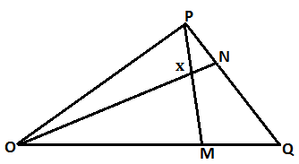

The figure above shows a triangle . Lines and **ON** meet at .

Given that**;**  and **.**

1. Express the following vectors in terms of and **.**

(06marks)

1. Given that; and By expressing in two

ways; find the values of and . (06 marks)

1. The Venn diagram below shows the number of guests who visited three

different regions in Uganda. The Northern region ); Central region and

the Western region ()

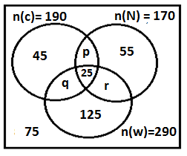

1. Determine the values of and . (06 marks)
2. Find the total number of guests. (02 marks)
3. Given that a guest is selected at random; find the probability that the

guest visited ;

1. both Central and Western regions
2. atmost two regions

(04 marks)

1. Micheal cycles from Kisigula to Kanoni starting at **8:00am** after one hour

while cycling at a uniform speed of ; he reached Kawempe and

rested for . He then continued cycling at the same speed for

another to Kanoni.

1. (i) What is Micheal’s average speed?

(ii) Using a scale of to represent and to represent

draw a distance – time graph showing Micheal’s journey.

1. If David decided to follow Micheal one and half hours later by a bodaboda

moving steadily at a speed of ; show his journey on the same axes.

From the graph determine;

1. when and what distance from Kisigula David over took Micheal?
2. their time of arrival at Kanoni.
3. for how long Micheal waited at Kanoni before David arrived.

(12 marks)

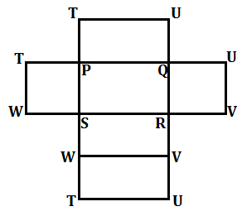

The figure above shows a rectangular prism whose base is ; and .

1. Sketch the figure . (03 marks)
2. Find the length (03 marks)
3. Find the angle between and the plane . (03 marks)
4. Find the angle between planes and plane . (03 marks)
5. In a certain country; income tax is computed after deducting the following allowances; from an employee’s gross monthly salary.

|  |  |
| --- | --- |
| **Type of allowance** | **Amount** |
| Housing | 80,000/= per month. |
| Transport and lunch | 45,000/= per month. |
| Medical | 900,000/= per annum. |
| Water and electricity | 1100/= per day. |

In addition to the above allowances: the employee is given a family allowance for only three children as seen below

|  |  |
| --- | --- |
| **Age** | **Amount** |
| 0 – 12 | 20,000/= |
| 13 – 18 | 15,000/= |
| Above 18 | 10,000/= |

Mr. Batamye has five children with the older child aged ; one with and the rest between and . His income tax is calculated as follows;

|  |  |
| --- | --- |
| **Income (Ushs)** | **Tax rate (%)** |
| 01 – 120,000 | 0 |
| 120,001 – 400,000 | 10 |
| 400,001 – 800,000 | 20 |
| 800,001 and above | 40 |

Given that Mr. Batamye paid a total income tax of for a month of

1. Calculate his;
2. gross monthly income. (08 marks)
3. net income (02 marks)
4. Express his income tax as a percentage of his gross monthly salary. (02 marks)

**END~**

**SUCCESS IS A STRUGGLE!**

